**Topic: Tours & Travel Management System**

**COURSE OBJECTIVE:**

* It is basically a desktop application.
* It is designed for one particular administrator.
* Through this system admin can manage the customer & also can keep the information of hotel availability.
* Ability for travelers to track all route details.
* From this system Admin can view daily, weekly and monthly report.
* This system is develop for admin who can add, delete, edit and view the data related to places, travels, routes, bookings from this system.

**FUNCTIONS REQUIRED:**

>> The administrative keeps all the details about hotel, route and customer.

>> To keep track of the route.

>> Keeping the details about the hotel.

>>>>Total no of rooms.

>>>>No of rooms available at the present.

>>>>No of rooms booked.

>>To keep all the details about the customer.

>>>>staying hotel name.

>>>> no. of rooms booked.

>>After leaving of any customer from the hotel the details will be deleted and upgrading the no of rooms available.

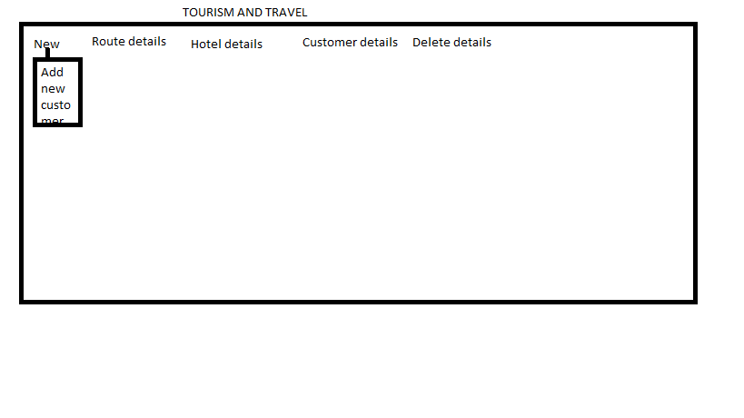

Route details

|  |  |
| --- | --- |
| Starting point | Destination |
|  |  |

Hotel details

|  |  |  |  |
| --- | --- | --- | --- |
| Name | Total rooms | No. of rooms booked | No. of rooms available |
|  |  |  |  |

Customer details

|  |  |  |  |
| --- | --- | --- | --- |
| Id | Name | Hotel name | No. of rooms booked |
|  |  |  |  |

Delete details

|  |  |  |
| --- | --- | --- |
| Customer name | Hotel name | No. of rooms booked |
|  |  |  |